2. BASIC CONCEPTS
WORKING FLUID: Fluid which is used thermodynamic analysis.
GAS | VAPOUR
T_{substance} > T_{critical} | T_{substance} < T_{critical}
Atmospheric Air is mixture of different gases
Eg. O2, N2, H2, He, Ar, etc...
So each Gas will be under same surrounding condition
Substance | Critical temperature |  | Critical pressure |  | Boiling temperature (1 atm) |  | Here All gas Have less than atmospheric temperature so all will be in GAS in atmospheric condition.  And Water will be in VAPOUR phase.
 | [°F] | [°C] | [psi], [lb/in²] | [bar] | [°F] | [°C]
Air | -220.94 | -140.52 | 549.08 | 37.858 | - | -
Argon | -188 | -122 | 705.6 | 48.7 | -302.5 | -.85.8
Hydrogen (H) | -400 | -240 | 188.2 | 13.0 | -423 | -253
Nitrogen (N) | -232.6 | -147 | 492.4 | 34.0 | -321 | -195
Oxygen (O₂) | -181.5 | -118.6 | 732 | 50.5 | -297 | -183
Helium (He) |  | -268 |  | 2.27
Water | 705 | 374 | 3206.2 | 220.5 | 212 | 100
IDEAL GAS: No intermolecular forces. (No Molecular Attractive Forces, Repulsive forces and other forces)
(F_{Intermolecular})_{Solid} >> (F_{Intermolecular})_{Liquid} >> (F_{Intermolecular})_{Gas}
KINETIC THORY OF GAS:
1) V_{GAS} <<<< V_{Container}
2) F_{Intermolecular} = 0
3) Collision between molecules are perfectly elastic ==> Zero Kinetic Energy loss/Gain
GAS BEHAVES AS IDEAL GAS: Pressure ˅, Volume ˄, Temperature ˅ And MFP ˅ (Z = 0)
At Atmospheric Condition, P_{atm} = 101.325 KPa, T_{atm} = 25 °C
Types of Ideal Gas
Perfect Ideal Gas | Semi Perfect Ideal Gas
Variation of specific heats (KJ/kg K) are not considered. OR specific heats are constant.  Eg. Air C_{p} = 1.005 KJ/kg K, C_{v} = 0.718 KJ/kg K | Variation of specific heats (KJ/kg K) Can’t ignore. So that Analysis at each and every temperature.

 | Boyle’s Law | Charles’ Law | Gay-Lussac Law
For given mass | P_{abs} ∝ 1/V_{gas} (@T=C) | V_{gas} ∝ T (@P_{abs}=C) | P_{abs} ∝ T (@V_{gas} = C)
PERFECT/ IDEAL GAS EQUATION:
P_{abs}v_{gas} = RT Where, P_{abs} = Absolute pressure of Gas (Pa)  v_{gas} = Specific Volume of Gas (m³/kg),  T = Absolute Temperature of Gas (K)  R = Characteristic Gas Constant (J/Kg K)  P_{abs}V_{gas} = mRT Where, V = Total Volume of Gas (m³)  m = Mass of the gas (kg)  P_{abs} = ρ_{gas}RT Where, ρ_{gas} = Density of Gas (kg/ m³) | If P (Pa), R (J/kg K).  If P (KPa), R (KJ/kg K).  R = 287 J/kg K (for Air)
MOLAR ANALYSIS:
Mole(n): Amount of substance. 1 mol = 6.023 * 10²³ Molecules
Molar Volume ($\overline{V}$): $\overline{V}$ = V_{gas}/n (m³ / Kmol)
Molar Mass ($\overline{m}$ ) Molar weight (M): M = $\overline{m}$ = m_{gas}/n (kg / Kmol)
Molar Gas Constant or Universal gas constant ($\overline{R}$): $\overline{R}=\overline{m} R=M R$(KJ / Kmol K)
P_{abs}$\overline{V}$ = $\overline{m}$ RT | P_{abs}$\overline{V}$ = $\overline{R}$T | P_{abs} V_{gas} = n$\overline{R}$T

AVOGADRO’S LAW: “Equal volume of all gases contains equal number of molecules at the same pressure and same temperature”
STP => P_{stp} = 1 atm = 101.325 KPa, T_{stp} = 0 °C = 273 K, V = 22.4 m³, n = 1Kmol => $\overline{R}$ = 8.314 KJ/Kmol K
Difference between Characteristic Gas constant and Universal Gas Constant:
Gas | Molar Mass (M) (kg/mol) | Universal gas constant ($\overline{R}$) (KJ / Kmol K) | Characteristic Gas constant (R) (KJ / kg K)
Air | 28.9 | 8.314 | 0.287
O2 | 32 | 8.314 | 0.259
N2 | 28 | 8.314 | 0.296
IDEAL GAS EQUATION FOR VARIOUS THERMODYNAMIC PROCESS:
Reversible Constant Volume/ Isochoric Process:  Rigid Tank,  V_{gas} = Constant,  Q_{supply} / Q_{rejected},  Eg. Football, Pressure Cooker, Automobile tyre, Automobile car, Both direction Locked Piston cylinder. | P_{abs} ∝ T (@V_{gas} = C)  Gay-Lussac Law | 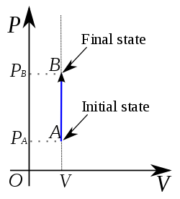
Reversible Constant Pressure/ Isobaric Process:  Assumptions:  1) Very Slow Process  2) Friction is neglected  3) No effect on gas due to weight of piston. W_{P} = 0  Rigid Tank,  P_{gas} = Constant,  Q_{supply} / Q_{rejected} (Expansion/Contraction)  Eg. Piston Cylinder Mechanism with weight less piston, Water heated in atmosphere, | V_{gas} ∝ T (@P_{abs}= C) Charles’ Law | 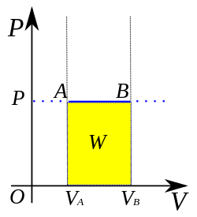
Combination of Constant Volume and Constant Pressure Process:  Assumptions:  1) Very Slow Process  2) Friction is neglected  3) Effect on gas due to weight of piston. W_{P} ≠ 0.  Two Process happed in index mentioned below when heat is supplied or rejected on one side locked piston:  1) Constant Volume Process  2) Constant Pressure Process | Process 1:  P_{abs} ∝ T (@V_{gas} = C)  Gay-Lussac Law  Process 2:  V_{gas} ∝ T (@P_{abs}= C)  Charles’ Law | Rectangle Triangle diagram.
Reversible Constant Temperature/ Isothermal Process:  In order to maintain constant temperature, Heat should be supplied or reject simultaneously.  This is not practically possible because:  1) Simultaneously Q_{supply} / Q_{rejected} is not possible.  2) Process is very slow process.  Eg. Boiling Water In atmosphere, Human Body (37 °C) | P_{abs} ∝ 1/V_{gas} (@T = C)  Boyle’s Law | 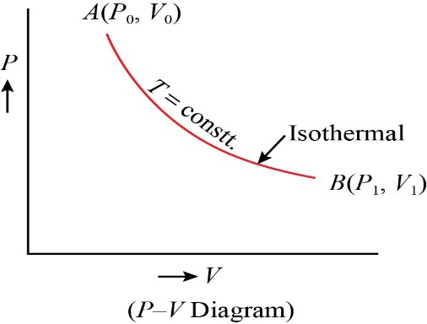Rectangular Hyperbola
Reversible Adiabatic Process:  No heat Transfer (Q_{supply} / Q_{rejected} = 0)  γ = adiabatic index | PV^{γ} = Constant  TV^{γ-1} = Constant  T$P^{\frac{γ}{γ-1}}$ = Constant  (because T ∝ PV) | γ = 1.67 (for mono-atomic Gas Eg. He, Ar)  γ = 1.4 (for die-atomic Gas Eg. H2, O2, N2)  γ = 1.33 (for Poly-atomic Gas Eg. CO2, CH4)
Reversible Polytropic Process:  Poly = many, Tropic = changes  Q_{supply} / Q_{rejected} ≠ 0  n = polytropic index | PV^{n} = Constant  TV^{n-1} = Constant  T$P^{\frac{1-n}{n}}$ = Constant  (because T ∝ PV) | 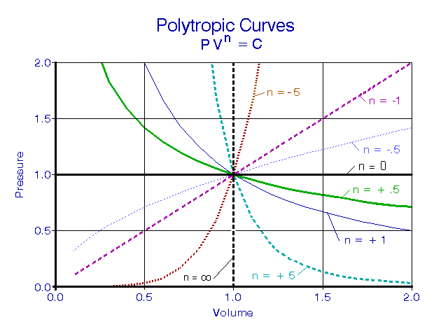
Adiabatic/ Polytropic index = ln(P₁/P₂)/ln(V₂/V₁)
Generally, 1 ≤ n ≤ γ. Actually, -∞ ≤ n ≤ ∞
Slope of Various Processes = dP/dV
n = 0 | n = 1 | n = γ | n = n | n = ∞
P = Constant | T = Constant | - | - | V = Constant
Isobaric | Isothermal | Adiabatic | Polytropic | Isochoric
${\left[\frac{dP}{dV}\right]}_{P}$= 0 | ${\left[\frac{dP}{dV}\right]}_{T}$= $-\left(\frac{P}{V}\right)$ | $\left[\frac{dP}{dV}\right]$= $-γ\left(\frac{P}{V}\right)$ =${ γ\left[\frac{dP}{dV}\right]}_{T}$ | $\left[\frac{dP}{dV}\right]$= $-n\left(\frac{P}{V}\right)$ = ${ n\left[\frac{dP}{dV}\right]}_{T}$ | ${\left[\frac{dP}{dV}\right]}_{V}$= ∞
THERMODYNAMICS TERMINOLOGY:
1. System: Quantity of Matter concentrated or under study.
2. Surroundings: Outside the system and effect on system is present.
3. Boundary: Surface which separates system and surroundings.
Types of Boundary
Fixed | Moving | Imaginary | Real
4. Universe: (System + Surroundings) put together.
FUNDAMENTAL DEFINATIONS IN THERMODYNAMICS:
1. State: Condition of system. (Denotes by point in diagrams)
2. Process: Change in State.
3. Path: Line which connects various state points.
4. Quasi Static Process: (Quasi = Almost, Static = Fixed) Extremely slow Process.
Each state is in equilibrium condition. dP = dV = 0 (For each successive states)
5. Reversible Process:
It’s Idealized or Hypothetical process.
When process is reversed follows same path. (Denotes by Solid/ Continuous line in diagram)
Condition for reversibility: 1) Quasi Static Process 2) Zero Friction loss 3) No effect of surrounding on system.
1) Integration is possible 2) Area Can be find for work obtain.
6. Irreversible Process: Process Which can’t reverse. System and surrounding presently affected.
(Denotes by Dotted/ Discontinuous line in diagram)
Condition for irreversibility: 1) Extremely Fast Process 2) Friction loss is present.
7. Thermodynamic Cycle: Series of processes which restores initial condition.
Thermodynamic Cycle
Reversible Thermodynamic Cycle | Irreversible Thermodynamic Cycle
All process in cycle must be reversible. | At least one process is Irreversible.
Thermodynamic Cycle
Work Producing Cycle (Clock wise) | Work Consuming Cycle (Anti-Clock wise)
8. Thermodynamic Equilibrium:
Thermodynamic Equilibrium | Thermal Equilibrium | Same Temperature throughout the system
 | Mechanical Equilibrium | Same Forces throughout the system
 | Chemical Equilibrium | No Chemical Reaction
PROPERTIES:
PROPERTIES
Extensive Property | Intensive Property
Depending on Mass and Size | Not Depending on Mass and Size
Mass, Volume, kinetic energy, Potential energy | Pressure, Temperature, Density, Viscosity, Thermal Conductivity, Electric Conductivity
1) Intensive Property = (Extensive Property/Extensive Property) 2) All Specific Property are Intensive property
Essential Features of Properties:
1) All Properties are point function. 2) Changes in property does not depend on path. 3) Properties are exact differentials. Eg. dP, dV,…
TYPES OF SYSTEM
Closed System | Open System | Isolated System
No Mass Transfer Allowed  Energy Transfer Allowed | Mass Transfer Allowed  Energy Transfer Allowed | No Mass Transfer Allowed  No Energy Transfer Allowed  But Work Transfer is allowed.
Eg. Closed Cointainer, Vessel, Balloons, Piston cylinder when valves are closed | Eg. Turbine, Compressor, Nozzle, Pipe Line. | Eg. Thermos Flask.
Controlled Volume: Region in the space consider for study.
Controlled Surface: Separates region from surroundings.

